

Infant, Toddler, Preschool, Kindergarten & School Age Programs
February 2020 Newsletter

In this Newsletter…
- Healthy Heart Day
- Vision Screening
- The Empowered Parent Program – FREE!
- SUMMER CAMP NEWS
- Preschool Advantage
- Tax Filing Help
- Tax ID #
- Valentine’s Day Festivities
- Presidents’ Day Closing
- Black History Month

Join us for Healthy Heart Day on
Friday, February, 7th from
7:00 A.M. - 6:00 P.M.
Healthy foods & resources will be available all day in our lobby!

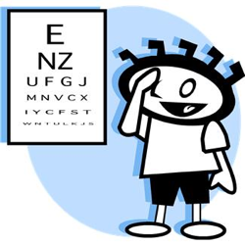
On Thursday, February 13th, we will partner with the Lions Club in order to provide a vision screening for our Preschoolers. This screening is FREE! See your child’s teacher for permission slips, which must be signed for participation in the screening.


Do you want to …
- learn new strategies to empower you as a parent?
- find new techniques that will help your family to communicate more effectively?
- understand what makes your child (of any age!) “tick”?
The Empowered Parent Program (provided in English & Spanish!) starts at 5:45 P.M. on
Thursday, March 5th.
*This 12-week program is FREE*
Stop by the front desk and see Daniela or Bea (Spanish) for more info!
~ SEE ATTACHED FLYER ~


Summer Camp Program information will be available by the week of February 17th – 21st. In addition to our regular summer programs for Toddler, Preschool, & School Age children, we will offer a Jr. Counselor Program for 11-13 year old youth!
*BE ON THE LOOKOUT*

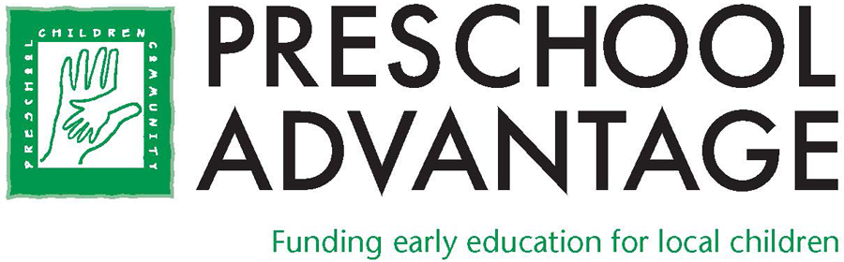
Our Center partners with Preschool Advantage, an organization that funds (3) ½ days per week of preschool during the school year! To find out if you qualify, please stop at the front desk for an application – or visit their website at www.preschooladvantage.org
or call 973-532-2501.
Their application deadline date is
March 1st, 2020.


United Way and its partners are helping ALICE (Asset Limited, Income Constrained, Employed) and poverty level individuals get the most from their federal & state tax returns by offering FREE TAX PREPERATION!
Call 973-993-1160 ext. 5 to make an appointment at a free tax site! Also, please pass along this info to anyone you might feel would benefit!


For your convenience, Mt. Olive Child Care & Learning Center’s

Tax I.D. # is 22-2157202


On Friday, February 14th, our children will celebrate Valentine’s Day with various activities! Please check with your child’s teacher for more information on what each individual classroom has planned!


Please remember that on Monday, February 17th, the CENTER WILL BE CLOSED for Presidents’ Day.
The staff will participate in a full day of professional development.


We encourage you to talk with your child about African-Americans who have made wonderful contributions to our lives. The public library is a great place for research. Our teachers will be incorporating great information in the monthly curriculum, too!

Look ahead to March …


- Daylight Savings Time begins March 8th
- Mt. Olive Public Schools CLOSED March 16th
- Spring Pictures
March 23rd & 24th

